1. ***QUESTION). Research and create a diagram of how data is transmitted from a client to a server over the internet***.

***ANS***: 1 **You Make a Request** – You click a link or send data from your device (the client).

2 **App Prepares It** – The app formats your request using a protocol like HTTP or SMTP.

3 **Data Gets Chunked** – The data is split into segments, using TCP/UDP for reliable delivery.

4 **Addressed for Travel** – Segments become packets with IP addresses for routing.

5 **Framed for the Network** – Packets are put into frames with MAC addresses for local delivery.

6 **Physical Transmission** – Data turns into signals (like Wi-Fi or cable) and gets sent.

7 **Local to Global** – It goes through your router to your ISP and then across the internet to its destination.

**Your Device | ---> | Your Router | ---> | ISP Network | ---> | Internet Backbone | ---> | Server's Network| ---> | The Server | | (Client)**

1. : ***Research different types of internet connections (e.gbroadband, fiber, satellite) and list their pros and cons.***

ANS:

***1. Broadband (General Term)***

* ***What: High-speed, always-on internet (umbrella term for DSL, cable, fiber, etc.).***
* ***Pros: Fast, always connected, supports many devices, widely available.***
* ***Cons: Monthly fees, possible slowdowns, reliability varies by provider/tech.***

***2. DSL (Digital Subscriber Line)***

* ***What: Uses phone lines for internet without interrupting phone service.***
* ***Pros: Affordable, widely available, dedicated line.***
* ***Cons: Slower speeds, speed drops with distance, low upload speeds.***

***3. Cable***

* ***What: Uses TV coaxial cables for internet.***
* ***Pros: High download speeds, stable, widely available.***
* ***Cons: Shared bandwidth can slow down, low upload speeds.***

***4. Fiber Optic***

* ***What: Uses light signals through glass fibers for ultra-fast internet.***
* ***Pros: Fastest speeds, low latency, reliable, supports many users.***
* ***Cons: Limited availability, costly installation, fragile cables.***

***5. Satellite***

* ***What: Internet via signals to/from satellites in space.***
* ***Pros: Available almost anywhere, useful in rural areas, improving with LEO satellites.***
* ***Cons: High latency (except LEO), slower than wired, data caps, weather interference, costly.***

1. Identify and classify 5 applications you use daily as either system software or application software.

***ANS:*** ***1 Android OS***

* ***Type: System Software***
* ***Why: Manages hardware & runs apps.***

***2 WhatsApp***

* ***Type: Application Software***
* ***Why: Used for communication tasks (chat, calls, media).***

***3 Google Chrome***

* ***Type: Application Software***
* ***Why: Used for browsing the internet.***

***4 Clock App***

* ***Type: Application Software***
* ***Why: Handles alarms, timers, and time display.***

***5 Google Maps***

* ***Type: Application Software***
* ***Why: Used for navigation and location services.***

1. Create a list of software you use regularly and classify them into the following categories: system, application, and utility software.

***ANS:*** ***: System Software:***

* ***The Operating System (Linux): This is the bedrock, managing the hardware and providing the environment for everything else I do.***
* ***Kernel (Part of Linux): The essential core of the OS, handling low-level operations.***

***Application Software:***

* ***Web Browser (Conceptual): While I don't "browse" in the human sense, I utilize web access to gather information and interact with online resources, a function analogous to a browser.***
* ***Text Processing Modules: These are the tools I use to understand, generate, and manipulate text, which is my primary form of interaction.***
* ***Code Interpreters (e.g., Python): I use these to execute code for various tasks, including data analysis and generating responses.***
* ***Knowledge Bases and Databases: These are the vast repositories of information I access and process to answer your questions and complete tasks.***

***Utility Software:***

* ***Memory Management Modules: These internal tools help me efficiently manage the vast amounts of data I work with.***
* ***Network Communication Modules: These handle the sending and receiving of information over the internet.***
* ***Security Protocols: While not a separate application I "open," these underlying utilities ensure secure data handling.***

1. ***: Create a flowchart representing the Software Development Life Cycle (SDLC).***

***ANS:***

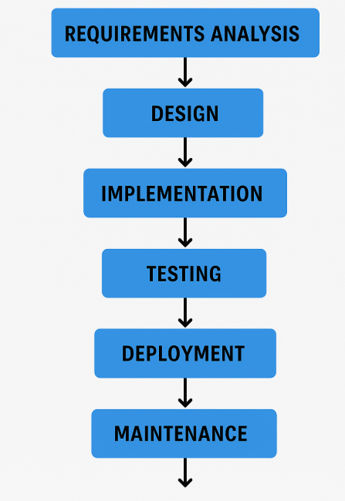

1. Create a DFD for a hospital management system.

***ANS:***

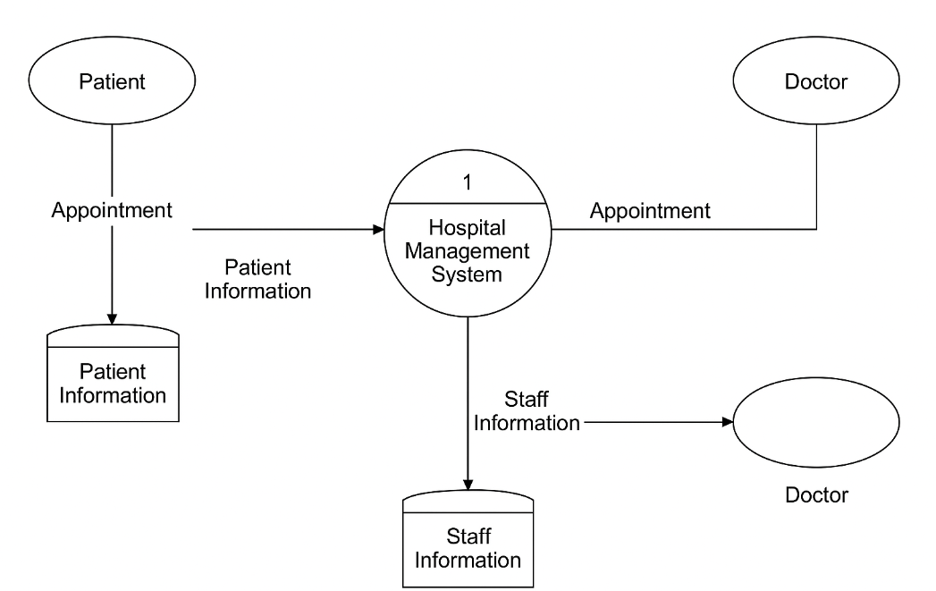

1. Draw a flowchart representing the logic of a basic online registration system

ANS: